1. Design PDA using simulator to accept the input string anbn

INPUT:

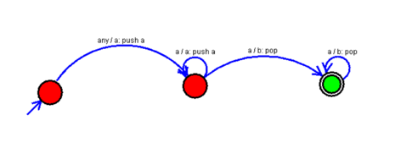

OUTPUT:

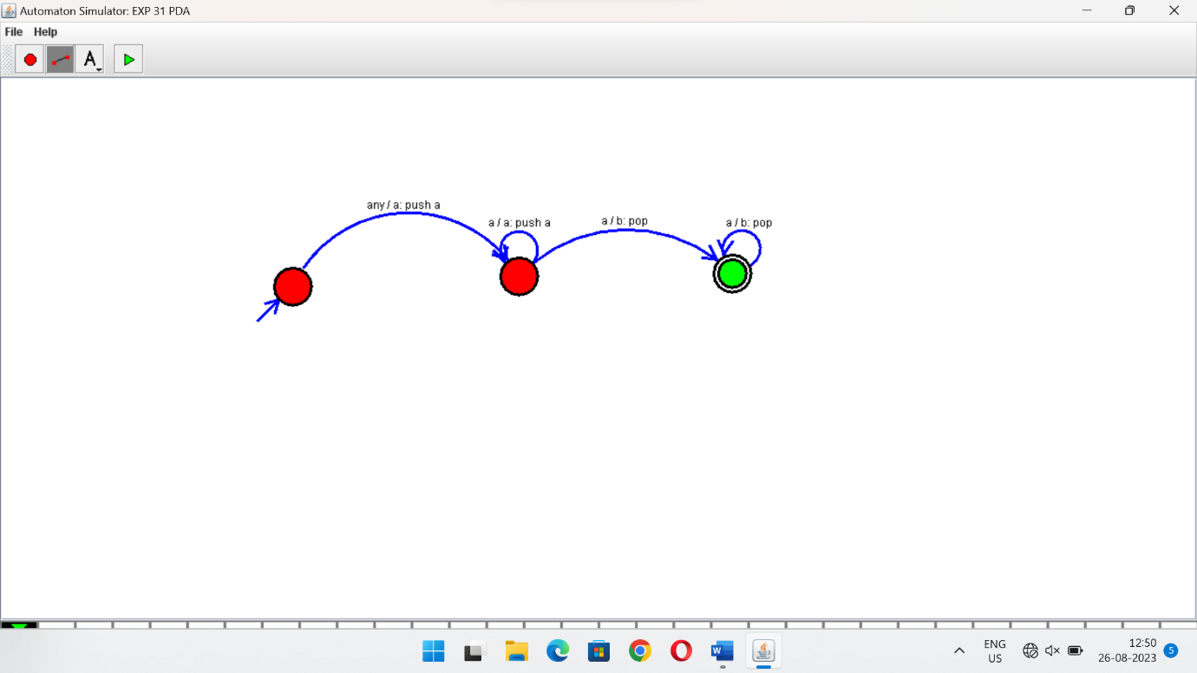

RESULTS:

PDA using simulator to accepting the input string anbn